**Project Report**

**On**

“online shopping system”

**Submitted in partial fulfillment for the award of the**

**DEGREE OF MASTER**

**IN**

**COMPUTER APPLICATIONS**

**2015-2017**

**Under the Guidance of: Submitted by:**

**Chairman Sumeet Kumar**

**Deptt. of CSE Enroll. No. 14012917 MCA**



**GURU JAMBESHWAR UNIVERSITY OF**

**SCIENCE AND TECHNOLOGY**

**HISAR-125001(HARYANA)**



**DECLARATION**

I hereby declare that the project entitles " **Online Shopping System**” Submitted in partial fulfillment of the requirements for award of the degree of **MCA** at GJUS&T, Hisar is an authentic work and has not been submitted to any other University for award of any degree/diploma.

**Sumeet Kumar**

**14012917**

**MCA**

**ACKNOWLEDGEMENT**

Knowledge is an endless ocean and one requires the satisfying, supporting, guiding, inspiring and constructively criticizing several specialists in order to drive out a handful pearls from its depth. As this comes wordlessly it can’t be acknowledged in words.

I am greatly obliged to Rcgemini Software**.** for providing me this opportunity to take up this project as long as a platform to learn and enhance my professional skill.

I would like to express my deep sense of gratitude to **Mr. Kamal Garag --** **Project Manager**, my corporate guide, for his kind help and support and valuable guidance throughout the project. I am thankful to him for providing me with necessary insights and helping me out at every single step.

**Sumeet Kumar**

**14012917**

**MCA**

online shopping

SYSTEM

ABSTRACT

Most students and parents today realize how expensive an education is. Whether you hope to study at a private high school, a college, university, or an overseas school, tuition costs plus the costs of books and living can quickly add up. If you are worrying about the cost of school, you should not feel that money has to decide your education.

If you want to study abroad in India, it is possible to obtain education loans. While getting these loans was difficult in the past, it has now become easier than ever before. A large number of national banks in India have created education loans. The terms of these loans will vary with each institution, so it is important to do your research before using them.

**TABLE OF CONTENTS**

**CHAPTER PAGE**

CERTIFICATES 2

ACKNOWLEDGMENTS 4

CHAPTERS

CHAPTER 1-Overview of the Organization 7

CHAPTER 2-Problem Definition 9

2.1- Profile of Problem Assigned

2.2- Objectives

2.3-Scope

2.4- Processing Environment

2.5-Acceptance Criteria

CHAPTER 3-Project Planning 12

3.1- Feasibility Analysis

3.2-Solution Strategy

3.3-Development Schedule

3.4-Introduction to PHP

CHAPTER 4-SRS and System Design 18

4.1-User Class and Characteristics

4.2-Functional Requirements

4.3-System design

4.4-DFD

CHAPTER 5-Detailed Design 27

5.1-Database Design

5.2-User Interface Design

5.3-Module Design

CHAPTER 6-Testing and Implementation 38

6.1-Testing

6.2-Implementation

CHAPTER 7-Maintenance 43

CHAPTER 8-Project Legacy 46

8.1-Current Status

8.2-Future

CHAPTER 9-Bibliography 47

**Chapter 1**

**Overview of the organization**

This project is being developed by a team of Infowiz developers and Infowiz trainees. INFOWIZ is an ISO certified US based company. It has been working from more than 5 years in the field of IT and Web Development and has been providing its clients with its exceptional and quality Web Design, Development and SEO services. Our clients range from individuals to professionals and small, medium and large scaled Businesses. In 2008, INFOWIZ entered into IT outsourcing and partnered successfully with many offshore web and SEO companies of US, UK, France, Ireland, Canada, and Australia etc. to provide them quality and timely services.

INFOWIZ does not boost itself of being the best development company but automatically enjoys reputable position among top Web Development companies because we of our timely delivery and quality work. We don’t claim for something we can’t deliver. Before taking a project from a client, we ask for all his needs and requirements. After that our skilled team of professionals analyzes the needs and comes up with a plan as how we can work to completely satisfy those requirements of our clients. We then work step by step keeping our client informed about the progress and complete the project in time giving complete contentment to them. From concept building to implementation of any project, our team manages the projects efficiently up to its completion. Our tactful strategy and dedication towards quality work has given us the recognition we enjoy and that is why our clients only come back to us whenever they require any kind of web related solutions. We do not only emphasize on formulating an attractive solution to our clients, but we believe in providing a workable solution. INFOWIZ is an organization which is established in the field of VLSI-VHDL, Embedded systems, PHP, .NET, Web Designing, Web Development, Network Support and Network training.

**VISION**

To be the leader in the industry oriented quality education and training and be the country’s premier institute for certification in the field of information, electronics and communications technology (IECT).

**MISSION**

Our mission is to be the best source for quality assurance in software education.

**OBJECTIVES**

1. Establish itself as an institute of excellence for imparting education and training to generate quality manpower in areas of information Electronics and communication technology (IECT).

2. Facilitate education and training institutes in the non-formal sector.

3. Develop a mechanism for dynamic revision of course curricula and development of the learning materials in the textbook, CD-ROM and web based form.

4. Impart continuing education/refresher training and corporate training to engineering graduates, working professionals and others.

5. Develop and implement new schemes of courses in emerging areas as required by industries and others.

6. Undertake develop projects and provide services in IT and related areas.

**Location**

The address of the company is S.C.O 94-95, Level -3, Behind Piccadilly Cinema Sector 34A, Chandigarh.

Contact numbers: 0172-4567-888

9888-500-888

9888-600-888

Email Id: www.infowiz.co.in

info@infowiz.co.in

**Chapter 2**

**Problem Definition**

**2.1 Profile of problem assigned**

In today’s busy world, people don’t have time for their personal needs. And the technology is so fast that anyone can do anything by just sitting in a room. The internet is the way that helps a person in all aspects. If someone wishes to buy and view things, he can buy online with the help of internet.

Today there are very least organizations which are manual. Everything is going to be computerized and online whether it is banking, advertising or shopping. We are trying to help people to make their life easier by proving online shopping of clothes

In this we have introduced many modules like admin module and customer module. The customer has to register for any enquiry related to clothes. The unregistered person can access this site and see the details about the clothes but before ordering anything they have to register. The registered customer can view details of clothes and he can buy the clothes of his choice and need. He has to pay the price of clothes.

The admin module contains the access of admin on the application. The admin can change everything in the application. He has the ability to add, delete, update any information regarding the clothes.

The project’s home page includes the registration link. The registered users can login to their account for their queries or buy new clothes. And the unregistered users have first to register. The registration can be done by following the login link.

**2.2 Objective**

The objective of our project is to develop an ecommerce site (online shopping) i.e. user friendly and which can be fit and used easily. This site help user to find the latest designed clothes for him. It is designed in such a way that admin can add, delete, update the clothes easily. The application will help user to see the clothes at anytime and anywhere when he needs. The user can access this site anywhere; he just needs the internet connection. This application includes other features also like

* To provide the security Low cost
* Free delivery of your order.
* Available for 24*7 hours.

**2.3 Scope**

This product has a great future scope. Online Shopping Internet Software developed on and for the Windows and later version environments like Linux etc. This project provides security with the use of the Login-id and Password so that any unauthorized user cannot access your account. The only authorized persons have the proper access authority to access this software.

**2.4 Processing environment**

Shopper site is business productivity site that helps users to see all the items when they want. Admin can see all the users who registered on his/her website. He can also see all the orders placed by the users. The users have to register on the website to place any order.

* How Registration Works?
* First of all users Registers themselves with the Site.
* Then after registration they can login on the website.
* They can see the products and there details and can place the order.

**2.5Acceptance Criteria:**

Acceptance criteria are an important yet, in my experience, often overlooked or undervalued aspect of the iterative planning process. Acceptance criteria are super important because projects succeed or fail based on the ability of the team to meet their customers documented and perceived acceptance criteria. When we clearly define acceptance criteria up front, we avoid surprises at the end of a sprint, or release, and ensure a higher level of customer satisfaction. Acceptance criteria

should be written from the perspective of the end-user or customer. That may seems obvious since user stories are written from the perspective of the end-user or customer. However, even for the

best-written stories, acceptance criteria are where the development and testing perspective seems to creep in.

Acceptance Criteria may reference what is in the project’s other User Stories or design documents to provide details, but should not be a re-hash of them. They should be relatively high-level while still providing enough detail to be useful. They should include:

* **Functional Criteria**: Identify specific user tasks, functions or business processes that must be in place. A functional criterion might be “A user is able to access a list of available reports.” A non-functional criterion might be “Edit buttons and Workflow buttons comply with the Site Button Design.”
* **Non-functional Criteria**: Identify specific non-functional conditions the implementation must meet, such as design elements. A non-functional criterion might be “Edit buttons and Workflow buttons comply with the Site Button Design.”
* **Performance Criteria:** If specific performance is critical to the acceptance of a user story, it should be included. This is often measured as a response time, and should be spelled out as a threshold such as “< seconds for a query response.

**Chapter-3**

**Project Planning**

**3.1 Feasibility Analysis**

“FEASIBILITY STUDY” is a test of system proposal according to its workability, impact of the organization, ability to meet needs and effective use of the resources. It focuses on these major questions:

* What are the user’s demonstrable needs and how does a candidate system meet them?
* What resources are available for given candidate system?
* What are the likely impacts of the candidate system on the organization?
* Whether it is worth to solve the problem?

During feasibility analysis for this project, following primary areas of interest are to be considered. Investigation and generating ideas about a new system does this.

**Technical feasibility**

A study of resource availability that may affect the ability to achieve an acceptable system. This evaluation determines whether the technology needed for the proposed system is available or not.

* Can the work for the project be done with current equipment existing software technology & available personal?
* Can the system be upgraded if developed?
* If new technology is needed then what can be developed?

This is concerned with specifying equipment and software that will successfully satisfy the user requirement.

The technical needs of the system may include

**a. Front-end and back-end selection**

An important issue for the development of a project is the selection of suitable front-end and back-end. When we decided to develop the project we went through an extensive study to determine the

most suitable platform that suits the needs of the organization as well as helps in development of the project.

The aspects of our study included the following factors:

* **Front-end selection:**

1. It must have a graphical user interface that assists employees that are not from IT background.

2. Scalability and extensibility.

3. Flexibility.

4. Robustness.

5. According to the organization requirement and the culture.

6. Must provide excellent reporting features with good printing support.

7. Platform independent.

8. Easy to debug and maintain.

9. Event driven programming facility.

10. Front end must support some popular back end like Microsoft SQL.

**b. Back-end Selection:**

1. Multiple user support.

2. Efficient data handling.

3. Provide inherent features for security.

4. Efficient data retrieval and maintenance.

5. Stored procedures.

6. Popularity.

7. Operating System compatible.

8. Easy to use.

9. Various drivers must be available.

10. Easy to implant with the Front-end.

According to above stated features we selected Microsoft SQL Server as the backend and windows 7 as the operating system. Language such as php and JavaScript is also used while making this project.

The technical feasibility is frequently the most difficult area encountered at this stage. It is essential that the process of analysis and definition be conducted in parallel with an

Assessment to technical feasibility. It centers on the existing computer system (hardware, software etc.) and to what extent it can support the proposed system.

**Economic feasibility**

Economic justification is generally the “Bottom Line” consideration for most systems. Economic justification includes a broad range of concerns that includes cost benefit analysis. In this we

weight the cost and the benefits associated with the candidate system and if it suits the basic purpose of the organization i.e. profit making, the project is making to the analysis and design

phase. The financial and the economic questions during the preliminary investigation are verified to estimate the following:

* The cost to conduct a full system investigation.
* The cost of hardware and software for the class of application being considered.
* The benefits in the form of reduced cost.

The proposed system will give the minute information, as a result the performance is improved which in turn may be expected to provide increased profits. This feasibility checks whether the system can be developed with the available funds. This project does not require enormous amount of money to be developed. This can be done economically if planned judicially, so it is economically feasible. The cost of project depends upon the number of man - hours required.

**Operational Feasibility**

It is mainly related to human organizations and political aspects. The points to be considered are:

* What changes will be brought with the system?
* What organization structures are disturbed?
* What new skills will be required? Do the existing staff members have these skills? If not, can they be trained in due course of time?

The system is operationally feasible as it very easy for the End users to operate it. It only needs basic information about Windows platform.

**Schedule feasibility**

Time evaluation is the most important consideration in the development of project. The time schedule required for the developed of this project is very important since more development time effect machine time, cost and cause delay in the development of other systems. A reliable system can be developed in the considerable amount of time.

**Management Feasibility**

The senior level officers are supportive in implement this project for motivation of clerical or no-technical employee.

**Legal Feasibility**

This project is not expected to violate any statute made under the Constitution of India.

**3.2 Solution Strategy**

The strategy followed is WATERFALL model the steps are:

1. Analysis of the module
2. Database Design
3. Front end design
4. Coding
5. Testing of modules
6. Integration of modules
7. Testing of entire system

**3.3 Development schedule**

In our project we are following the top down approach and working according to its flow. Steps of that project plan are in the below explained order:

* Firstly we have learnt the technologies that were required in order to complete the project.

That is HTML, CSS, JavaScript, jQuery, PHP for the front end, working with SQL server for Backend and the tool we are using for this is DREAMWEAVER. The order in which we have learnt the technology is:

1. Concepts of HTML, CSS
2. Concepts of JavaScript
3. Introduction to PHP
4. Working with SQL
5. Working with JQuery, Ajax

**3.4 Introduction to PHP**

* PHP stands for **P**HP: **H**ypertext **P**reprocessor
* PHP is a server-side scripting language, like ASP
* PHP scripts are executed on the server
* PHP supports many databases (MySQL, Informix, Oracle, Sybase, Solid, Generic ODBC, etc.)
* PHP is an open source software
* PHP is free to download and use

**Characteristics of PHP: -**

* Readable – Being able to easily read code is vital. Don’t ever assume you will be the only developer to ever read and maintain your code. I can’t think of a single project for the exception of my blog that I have been the only one who worked on it. Readable code has meaningful variables; good comments that help describe what’s going on. However, good variables and comments don’t necessarily mean your code is readable.
* reorganized – While some people think this is the same as readable, organization is different and crucial to me. Readability is the ability to read your code, however organized code helps you find what you are looking for. There are many techniques to help keep your code well organized, but the most important thing is at the end of the day, can your fellow developers find what they are looking for?
* Modular – I hear this word tossed around a lot when talking about programming. However, what really is modular? I like to define it as being able to take a part of your code and use it elsewhere with the least amount of headache.
* Relevant – While I hear a lot about Modular code, I don’t hear a lot about relevant code. While people might consider relevant in the modular or organized characteristic, I find it
* helps me to separate this out. Relevant to me means that code is where it belongs. Its easy to have code blur together and have purposes mixed. Relevant code means the grouping of code belongs together.
* Efficient – What good is code if it is slow, doesn’t scale, and will have to be re-written? Is being efficient is just following a handful of rules and guidelines?
* Practical – It may be efficient, it be organized, but is it practical? In the past I’ve written the “coolest” class, or so I thought, only to have a fellow developer tell him that my implementation is confusing, and overly complex. While many times we create code that isn’t robust enough, but it is possible to make stuff just complicated, over-designed, or just impractical. Keeping your code practical helps you and your team to make a good solution that is easy to maintain.
* Documented – Code that isn’t well documented will be a time drain. I know many developers who think keeping up documentation slows the development process down.
* However, without that documentation, the overall development process will suffer. Bringing new developers up to speed, maintenance, even just general development will be slowed down by “figuring stuff out.” Documentation is also more than just having a “wiki” or using comments.
* Longevous – The definition is to live a long life. There are two parts to having longevous code. First of all, when you’ve programmed or maintained some code, ask yourself. “How long will this last? Will this solution work well over time?” Then, the second part which I think is almost never asked: “when the time comes, how easily can I extend, or replace this
* Code- To often programmers “dig ruts” so-to-speak in projects. They code an aspect of a project that locks them into a situation that is extremely difficult to code out of.
* Secure – All of the time spent on development can be for nothing if it isn’t secure. Security in web development is a must. It doesn’t matter the size of the website, large or small, eventually someone will try to break it. Someone will try to compromise it. The consequences vary, from an annoyance, to destroying the entire business. Making your application secure is a skill all developers need.
* Safe – While some people think of this as the same as secure, for me safe PHP code means it handles errors correctly. Great PHP code handles errors correctly. If a PHP class fails, it should handle the error properly. It should also throw errors correctly when needed. If code is safe, I know that it will behave as it should, and properly let me know when it is not

**Applications of PHP: -**

*Web Database Applications with PHP and MySQL* offers web developers a mixture of theoretical and practical information on creating web database applications. Using PHP, and MySQL, two open source technologies that are often combined to develop web applications, the book offers detailed information on designing relational databases and on web application architecture, both of which will be useful to readers who have never dealt with these issues before. The book also introduces Hugh and Dave's Online Wines, a complete (but fictional) online retail site that allows users to browse, search a database, add items to a shopping cart, manage their membership, and purchase wines. Using this site as an example, the book shows you how to implement searching and browsing, store user data, validate user input, manage transactions, and maintain security.

**Chapter-4**

**SRS and System Design**

* System requirements are expressed in a software requirement document. The Software requirement specification (SRS) is the official statement of what is required of the system developers. This requirement document includes the requirements definition and the requirement specification. The software requirement document is not a design document. It should set out what the system should do without specifying how it should be done. The requirement set out in this document is complete and consistent. The software specification document satisfies the following: -
* It specifies the external system behaviors.
* It specifies constraints on the implementation.
* It is easy to change.
* It serves as reference tool for system maintainers.
* It record forethought about the life cycle of the system.
* It characterizes acceptable response to undesired events.

**4.1 User Class and Characteristics:**

* General public
* Customers
* Administrator
* General public can use the system to see the product, their prices and quantity available.
* General user cannot buy the products.
* Customers are using for viewing and buying the products.
* Customer can also write feedbacks for products and services
* Administrators can add, edit & delete products .and provide services to the customer.
* Administrator can see the daily sell. Can also see the feedback given by the customer.
* **4.2 Functional Requirements:**

* The System must provide following functionalities
* Keeping records of admission of customers.
* Keeping the records of products.
* Keeping the daily sell.
* Storing the feedback given by the customer.
* Keeping details about the product it is delivered or not. etc.
* Storing the items selected by the customer in the temporary storage

**4.3 System Design**

* System design is the process of defining the elements of a system such as the architecture, modules and components, the different interfaces of those components and the data that goes through that system. It is meant to satisfy specific needs and requirements of a business or organization through the engineering of a coherent and well-running system. Systems design implies a systematic approach to the design of a system. It may take a bottom-up or top-down approach, but either way the process is systematic wherein it takes into account all related variables of the system that needs to be created from the architecture, to the required hardware and software, right down to the data and how it travels and transforms throughout its travel through the system. Systems design is simply the design of systems. It implies a systematic and rigorous approach to design—an approach demanded by the scale and complexity of many systems problems. The design of an information system produces the details that state how a system will meet the requirements identified during system analysis. The process is begun by identifying reports and other outputs the system will produce. The system design also describes the data to be input, calculated or stored. It also specifies the input forms and screen layouts for all actions that a user performs on the system. The design can be-

**Physical Design:**

The physical design relates to the actual input and output processes of the system. This is laid down in terms of how data is input into a system, how it is verified/authenticated, how it is processed, and how it is displayed as In Physical Design, the following requirements about the system are decided :.

1. Input requirement
2. Output requirements
3. Storage requirements
4. Processing Requirements
5. System control and backup or recovery

**Logical Design**

The logical design of a system pertains to an abstract representation of the data flows, inputs and outputs of the system. This is often conducted via modeling, using an over-abstract model of the actual system. In the context of systems design are included. Logical design includes ER Diagrams i.e. Entity Relationship Diagrams.

**4.4 DFD**

A data flow diagram shows the logical flow of the system. For a system it describes the input (source), output (destination), database (data stores) and procedures (data flows) all in a format that meets the user’s requirement. When analysis prepares the logical system design, they specify the user needs at a level of detail that virtually determines the information flow into an out of the system and the required data resources. The logical design also specifies input forms and screen layouts. The activities following logical design are the procedure followed in the physical design e.g., producing programs, software, file and a working system. Design specifications instruct the user about what the system should do. Data Flow Diagramming is a means of representing a system at any level of detail with a graphic network of symbols showing data flows, data stores, data processes, and data sources/destination. The data flow diagram is analogous to a road map. It is a network model of all possibilities with different detail shown on different hierarchical levels. This processes of representing different details level is called “leveling” or “partitioning” by some data flow diagram advocates. Like a road map, there is no starting point or stop point, any time or timing, or steps to get somewhere. We just know that the data path must exist because at some point it will be needed. A road map shows all existing or planned roads because the road is needed. Details that is not shown on the different levels of the data flow diagram such as volumes, timing, frequency, etc. is shown on supplementary diagrams or in the data dictionary. For example, data store contents may be shown in the data dictionary.

**Flow chart symbols: -**

|  |  |  |
| --- | --- | --- |
| **Symbols** | **Description** | **Representation** |
| Terminal | To show beginning and end of a set of computer related processes. |  |
| Computer processing | To indicate any processing performed by a computer system. |  |
| Input/output | To show any input/output operation. |  |
| Magnetic disk | To represent any data on magnetic disc. |  |
| Decision | To show any point in the process where a decision must be made to determine further action. |  |
| Directional flow | To show the direction or sequence of processing and other events. |  |

1. **Data flow diagram symbols: -**

|  |  |  |
| --- | --- | --- |
| **Symbols** | **Description** | **Representation** |
| Process | To show people, procedures, devices that produce or use data. |  |
| Source/Destination | To show external sources or destination of data. |  |
| Data store | To store data. |  |
| Data flow | To show the flow of data from origin to destination |  |

1. **ER Diagram**

In this design approach the system is viewed as a collection of entities (objects). Each object manages its own properties (attributes) and state. The entity-relationship diagram is a data modeling technique that graphically represents information systems entities and the relationships between those entities. An ER diagram is a conceptual and representational model of data which is used to represent the system framework infrastructure.

The ER diagram contains following elements: Entities, Relationships and Attributes. In designing the ER diagram, I identify and define all the entities, determine the interactions between the entities and determine the cardinality of the relationship.

|  |  |  |
| --- | --- | --- |
| **Symbols** | **Description** | **Representation** |
| Entity | To show person or devices |  |
| Attributes | To show the features of an entity |  |
| Relation | To show relationship between two entities |  |
| Data flow | To connect an entity with its attributes or any other entity |  |

**1.Use case Diagram for Administrator:**

**Administrator**

**Data Flow Diagrams**

1. **Level 0 DFD**

**Database**

**Administrator**

1. **Level 1 DFD**

**ADMIN**

**Show Products**

**Figure 2.**DFD to show how Admin works.

**USER**

**III**

**My Cart**

**My Account**

**Register**

**Figure 3.**DFD to show how users register, login and create their profile and do shopping.

**ADMIN**

**Home Page**

**Login: Whether admin or user**

**User**

**Admin**

**Products**

**My Account**

**Show Users**

**My Cart**

**Show Products**

**Add/update/delete products**

**Show Orders**

**Figure 4.**DFD to show working of shopping site.

**Chapter-5**

**Detailed Design**

**5.1 Database Design**

### MySQL

### 1. Scalability and Flexibility

The MySQL database server provides the ultimate in scalability, sporting the capacity to handle deeply embedded applications with a footprint of only 1MB to running massive data warehouses holding terabytes of information. Platform flexibility is a stalwart feature of MySQL with all flavors of Linux, UNIX, and Windows being supported. And, of course, the open source nature of MySQL allows complete customization for those wanting to add unique requirements to the database server.

### 2. High Performance

A unique storage-engine architecture allows database professionals to configure the MySQL database server specifically for particular applications, with the end result being amazing performance results. Whether the intended application is a high-speed transactional processing system or a high-volume web site that services a billion queries a day, MySQL can meet the most demanding performance expectations of any system. With high-speed load utilities, distinctive memory caches, full text indexes, and other performance-enhancing mechanisms, MySQL offers all the right ammunition for today's critical business systems.

**3. High Availability**

Rock-solid reliability and constant availability are hallmarks of MySQL, with customers relying on MySQL to guarantee around-the-clock uptime. MySQL offers a variety of high-availability options from high-speed master/slave replication configurations, to specialized Cluster servers offering instant failover, to third party vendors offering unique high-availability solutions for the MySQL database server.

In this project, the database name is online and it includes these tables:

* add product
* booking
* demo
* feedback
* images
* register

**Register table:**

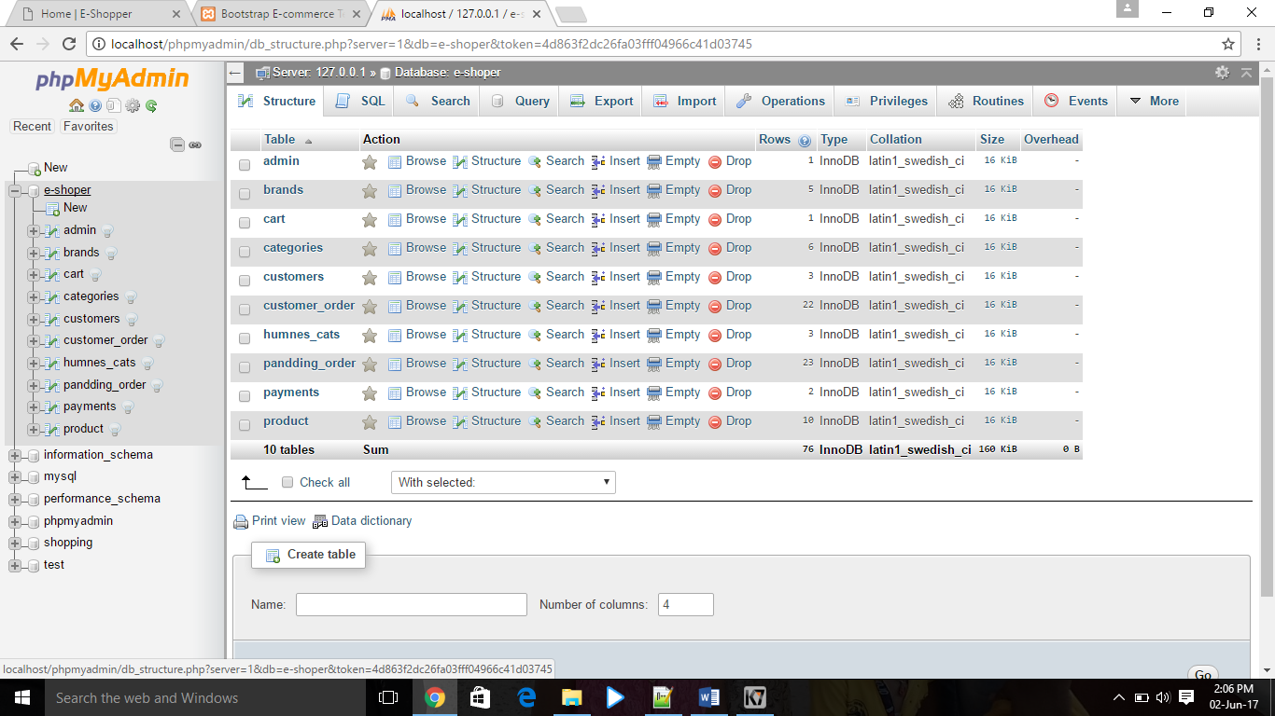

**Entries:**

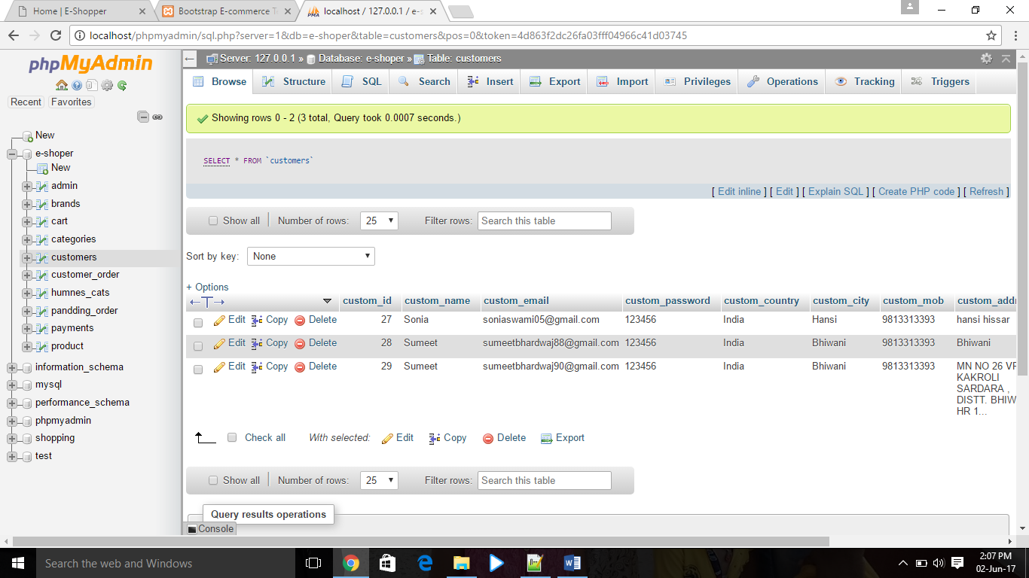

**Add product table:**

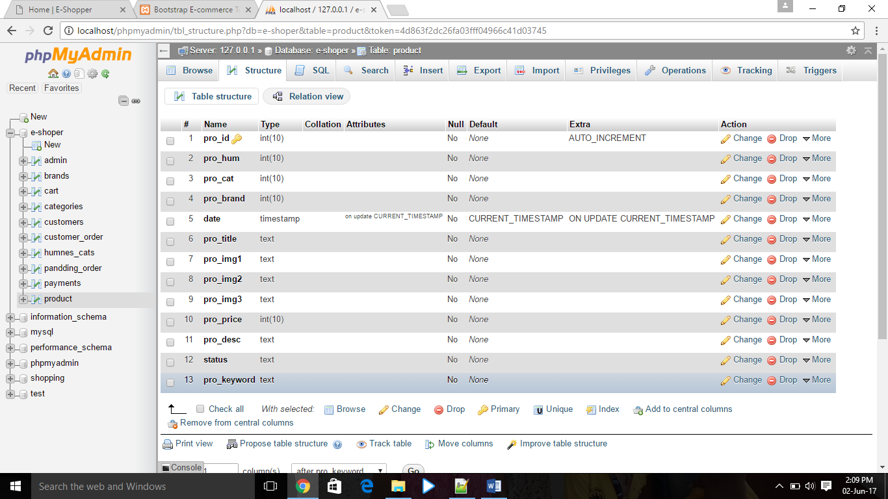

**Entries:**

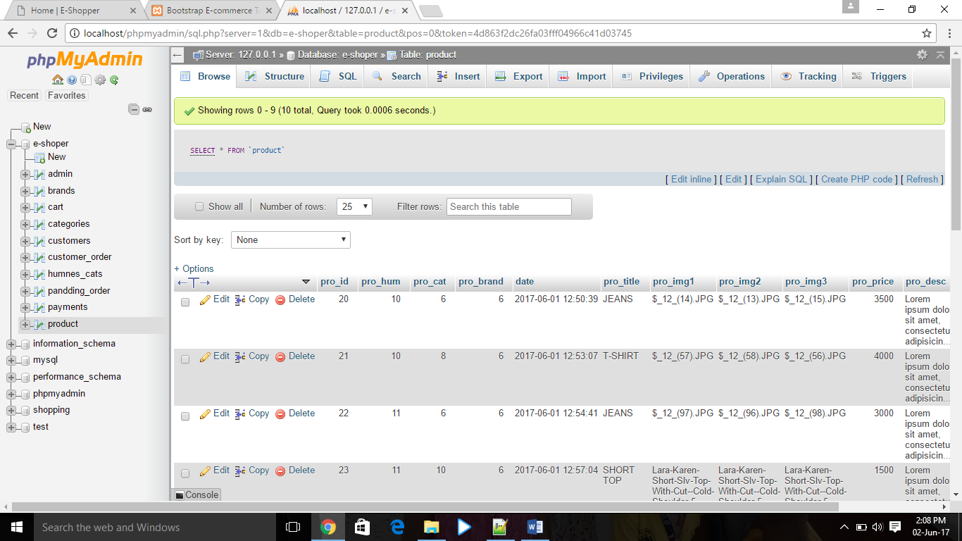

**Add To Cart table:**

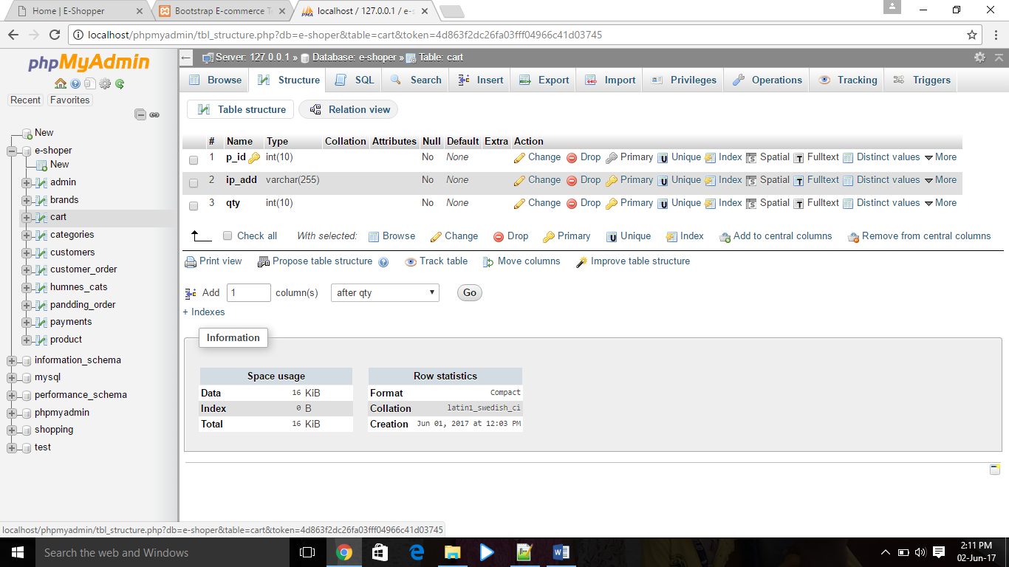

**Entries:**

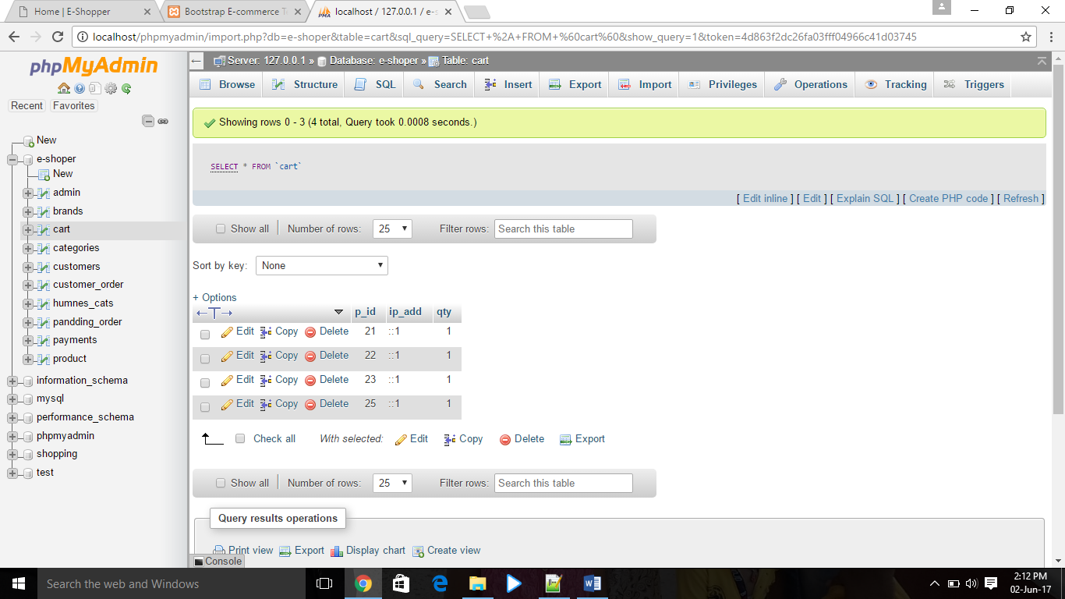

**Apache Server**

The Apache HTTP Server, colloquially called Apache is the world's most used web server software. Originally based on the NCSA HTTP server, development of Apache began in early 1995 after work on the NCSA code stalled. Apache played a key role in the initial growth of the World Wide Web, quickly overtaking NCSA HTTP as the dominant HTTP server, and has remained most popular since April 1996. In 2009, it became the first web server software to serve more than 100 million websites. Apache is developed and maintained by an open community of developers under the auspices of the Apache Software Foundation. Most commonly used on a Unix-like system (usually Linux),the software is available for a wide variety of operating systems besides Unix, including Eco Station, Microsoft Windows, NetWare, OpenVMS, OS/2, and TPF. Released under the Apache License, Apache is free and open-source software. Apache supports a variety of features, many implemented as compiled modules which extend the core functionality. These can range from server-side programming language support to authentication schemes. Some common language interfaces support Perl, Python, TCL, and PHP. Popular authentication modules include mod access, mod_auth, mod_digest, and mod_auth_digest, the successor to mod_digest. A sample of other features include Secure Sockets Layer and Transport Layer Security support

(mod_ssl), a proxy module (mod_proxy), a URL rewriting module (mod_rewrite), custom log files (mod_log_config), and filtering support (mod_include and mod_ext_filter).

Popular compression methods on Apache include the external extension module, mod_gzip, implemented to help with reduction of the size (weight) of Web pages served over HTTP. Mod Security is an open source intrusion detection and prevention engine for Web applications. Apache logs can be analyzed through a Web browser using free scripts, such as AWStats/W3Perl or Visitors. Virtual hosting allows one Apache installation to serve many different Web sites. For example, one machine with one Apache installation could simultaneously serve www.example.com, www.example.org, test47.test-server.example.edu, etc. Apache features configurable error messages, DBMS-based authentication databases, and content negotiation. It is also supported by several graphical user interfaces (GUIs). It supports password authentication and digital certificate authentication. Because the source code is freely available, anyone can adapt the server for specific needs, and there is a large public library of Apache add-ons.

**5.2 User Interface Design**

User interface design is the design of user interfaces for machines and software, with the focus on maximizing the user experience. The goal of user interface design is to make the user's interaction as simple and efficient as possible, in terms of accomplishing user goals (user-centered design). Good user interface design facilitates finishing the task at hand without drawing unnecessary attention to itself. Graphic design and typography are utilized to support its usability, influencing how the user performs certain interactions and improving the aesthetic appeal of the design; design aesthetics may enhance or detract from the ability of users to use the functions of the interface. The design process must balance technical functionality and visual elements (e.g., mental model) to create a system that is not only operational but also usable and adaptable to changing user needs. Interface design is involved in a wide range of projects from computer systems, to cars, to commercial planes; all of these projects involve much of the same basic human interactions yet also require some unique skills and knowledge. As a result, designers tend to specialize in certain types of projects and have skills centered on their expertise, whether that be software design, user research, web design, or industrial design. User interface design requires a good understanding of user needs.



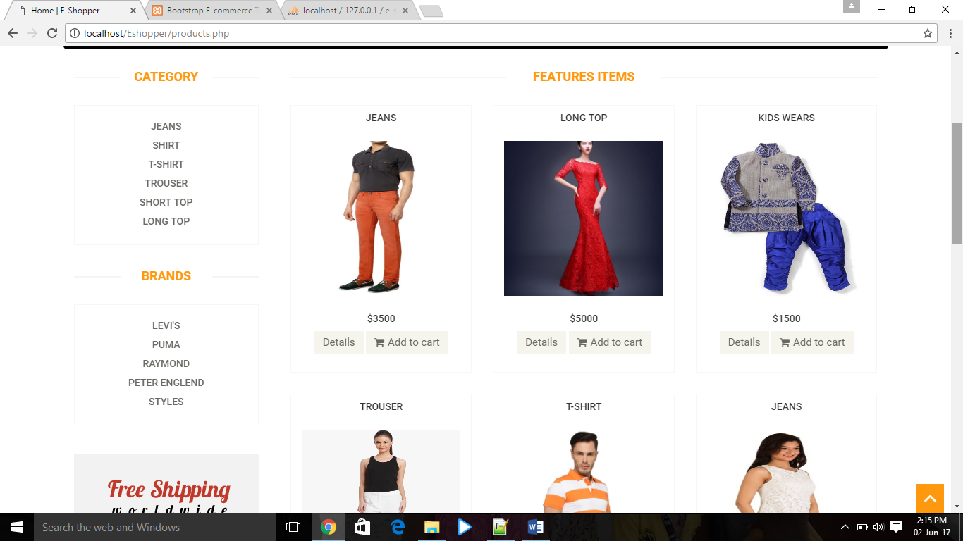

* In this the registered user can view All the Products.
* The user can see his account and can update it.
* The user can send the feedback.
* The user can see all his orders.
* The users can logout at any time when he wants.

**5.3 Module Design**

**About Client Module**

**Client: -** Client can perform the two tasks on this site.

* He can see all the products available on this site with their features and prices. He can register for purchasing the product.
* He can give feedback using his account.
* He can see all his orders.
* He can also update his account whenever he wants.

**About Administrator Module**

* **Admin: -** Administrator can Perform the two task on this site.
* He can manage all the products.
* He can respond to user request.
* He can put the new products, update the existing and can also delete them from the site.

**Chapter 6**

**Testing and Implementation**

**6.1 TESTING**

Software testing is the process of evaluation a software item to detect differences between given input and expected output. Also to assess the feature of a software item. Testing assesses the quality of the product. Software testing is a process that should be done during the development process. In other words software testing is a verification and validation process.

**Verification**

Verification is the process to make sure the product satisfies the conditions imposed at the start of the development phase. In other words, to make sure the product behaves the way we want it to.

**Validation**

Validation is the process to make sure the product satisfies the specified requirements at the end of the development phase. In other words, to make sure the product is built as per customer requirements.

**Basics of software testing**

There are two basics of software testing: black box testing and white box testing.

**Black box Testing**

Black box testing is a testing technique that ignores the internal mechanism of the system and focuses on the output generated against any input and execution of the system. It is also called functional testing.

**White box Testing**

White box testing is a testing technique that takes into account the internal mechanism of a system. It is also called structural testing and glass box testing.

Black box testing is often used for validation and white box testing is often used for verification

**6.1.2 Types of testing**

There are many types of testing like

* Unit Testing
* Integration Testing
* Functional Testing
* System Testing
* Stress Testing
* Performance Testing
* Usability Testing
* Acceptance Testing
* Regression Testing
* Beta Testing
* **Unit Testing**

Unit testing is the testing of an individual unit or group of related units. It falls under the class of white box testing. It is often done by the programmer to test that the unit he/she has implemented is producing expected output against given input.

* **Integration Testing**

Integration testing is testing in which a group of components are combined to produce output. Also, the interaction between software and hardware is tested in integration testing if software and hardware components have any relation. It may fall under both white box testing and black box testing.

* **Functional Testing**

Functional testing is the testing to ensure that the specified functionality required in the system requirements works. It falls under the class of black box testing.

* **System Testing**

System testing is the testing to ensure that by putting the software in different environments (e.g., Operating Systems) it still works. System testing is done with full system implementation and environment. It falls under the class of black box testing.

* **Stress Testing**

Stress testing is the testing to evaluate how system behaves under unfavorable conditions. Testing is conducted at beyond limits of the specifications. It falls under the class of black box testing.

* **Performance Testing**

Performance testing is the testing to assess the speed and effectiveness of the system and to make sure it is generating results within a specified time as in performance requirements. It falls under the class of black box testing.

* **Usability Testing**

Usability testing is performed to the perspective of the client, to evaluate how the GUI is user-friendly? How easily can the client learn? After learning how to use, how proficiently can the client perform? How pleasing is it to use its design? This falls under the class of black box testing.

* **Acceptance Testing**

Acceptance testing is often done by the customer to ensure that the delivered product meets the requirements and works as the customer expected. It falls under the class of black box testing.

* **Regression Testing**

Regression testing is the testing after modification of a system, component, or a group of related units to ensure that the modification is working correctly and is not damaging or imposing other modules to produce unexpected results. It falls under the class of black box testing.

* **Beta Testing**

Beta testing is the testing which is done by end users, a team outside development, or publicly releasing full pre-version of the product which is known as beta version. The aim of beta testing is to cover unexpected errors. It falls under the class of black box testing.

* **Extent of Software Testing**

The basic job of software testing is to identify errors in order to reveal and spot it. The extent of software testing consists of implementation of that code in different domain and also to look at the features of the code does the software do what it is should be done and methods respect to the

condition. It is proposed to begin testing from the first phase of the software development. This is not only aids in correcting the faults earlier to the last step, but also decrease the reworking of getting errors in the first step every time. It saves time as well as cost. It is a continuous method, which is probably nonstop but has to be stopped anywhere, for the need of time and resources. The basic need of the testing is to provide best quality product without taking so much time and money.

The test engineer has to pursue some technical way by which he/she can review that all the points of necessity for testing have been covered or not. A register should be created for keeping records of the day to day test cases. Presently in the IT Field, a testing group might be divided from the development team. There are several roles for testing team members. Whatever outcome derivative from testing may be used to accurate software development process.

* **Estimating Software Testing**

There is requirement for estimating the software, at the phase of implementation as well as after the software is completed for deliver. Though it is very complicated to estimate the conceptual controls but the controls are also very important to do estimation. The components that cannot be estimated have to be restricted. There are some vital uses of estimating the system.

Software estimation is used to defeat hazard such as:

* Cost exceeds.
* Identifying the problem raised part.
* Illuminating objectives
* It also find out:
* Evaluation of every act of the system.
* Standards of the code which are involved to develop.
* Way of upgrade the under implemented codes.

**6.2 Implementation**

Implementation is the stage of the project where the theoretical design is turned into a working system. It can be considered to be the most crucial stage in achieving a successful new system gaining the users confidence that the new system will work and will be effective and accurate. It is primarily concerned with user training and documentation. Conversion usually takes place about the same time the user is being trained or later. Implementation simply means convening a new system design into operation, which is the process of converting a new revised system design into an operational one. Implementation is the stage of the project where the theoretical design is tuned into a working system. At this stage the main work load, the greatest upheaval and the major impact on the existing system shifts to the user department. If the implementation is not carefully

planned and controlled it can create chaos and confusion. Implementation includes all those activities that take place to convert from the existing system to the new system. The new system may be a totally new, replacing an existing manual or automated system or it may be a modification to an existing system. Proper implementation is essential to provide a reliable system to meet organization requirements. The process of putting the developed system in actual use is called system implementation. This includes all those activities that take place to convert from the old system to the new system. The system can be implemented only after through testing is done and if it is found to be working according to the specifications. The system personnel check the feasibility of the system.

The more complex the system being implemented, the more involved will be the system analysis and design effort required to implement the three main aspects: education and training, system testing and changeover.

The implementation state involves the following tasks:

* Careful planning.
* Investigation of system and constraints.
* Design of methods to achieve the changeover.
* Training of the staff in the changeover phase.

**Implementation Procedures**

Implementation of software refers to the final installation of the package in its real environment, to the satisfaction of the intended uses and the operation of the system. In many organizations someone who will not be operating it, will commission the software development project. In the initial stage people doubt about the software but we have to ensure that the resistance does not build up, as one has to make sure that

* The active user must be aware of the benefits of using the new system.
* Their confidence in the software is built up.
* Proper guidance is imparted to the user so that he is comfortable in using the application.

Before going ahead and viewing the system, the user must know that for viewing the result, the server program should be running in the server. If the server object is not up running on the server, the actual process won’t take place.

**Chapter-7**

**Maintenance**

Once the site is launched, it enters the maintenance phase. All systems need maintenance. Maintenance is required because there are often some residual errors remaining in the system that must be removed as they are discovered. Maintenance involves understanding the effects of the change, making the changes to both the code and the documents, testing the new parts and retesting the old parts that were not changed. Maintenance involves understanding the existing software (code and related documents), understanding the effects of change-to both the code and the documents testing the new parts (changes), and retesting the old parts that were not changed. Because often during development the needs of the maintenance are not kept in mind, few support documents are produced during development to help maintainers. Maintenance is basically of three types:

7.1 Corrective Maintenance

7.2 Adaptive Maintenance

7.3 Perfective Maintenance

7.4 Predictive Maintenance

**7.1 CORRECTIVE MAINTENANCE**

It is commonly believed that the state of the art today is such that almost all software that is developed has residual errors, or bugs, in them. Many of these surfaces only after the system have been developed and have been in operation, sometimes for a long time. Corrective maintenance is a maintenance task performed to identify, isolate, and rectify a fault so that the failed equipment, machine, or system can be restored to an operational condition within the tolerances or limits established for in-service operations.

**7.2** **ADAPTIVE MAINTENANCE**

It has been argued that once a software system is deployed, the environment in which it operates changes. Hence, the Needs that initiated the software development also changes to reflect the needs of the new environment. The changed software then changes the environment, which in turn requires future change.

**7.3 PERFECTIVE MAINTENANCE**

A software product needs maintenance to support the new features that the users want or to change different functionalities of the system according to the customer needs.

Perfective maintenance involves making enhancements to improve processing performance, interface usability, or to add desired, but not necessarily required, system features. The objective of perfective maintenance is to improve response time, system efficiency, reliability, or maintainability. During system operation, changes in user activity or data pattern can cause a decline in efficiency, and perfective maintenance might be needed to restore performance. Usually, the perfective maintenance work is initiated by the IT department, while the corrective and adaptive maintenance work is normally requested by users.

**7.4 PREDICTIVE MAINTENANCE**

Predictive maintenance techniques are designed to help determine the condition of in-service equipment in order to predict when maintenance should be performed. This approach promises cost savings over routine or time-based preventive maintenance, because tasks are performed only when warranted. The main promise of Predicted Maintenance is to allow convenient scheduling of corrective maintenance, and to prevent unexpected equipment failures. The key is "the right information in the right time". By knowing which equipment needs maintenance, maintenance work can be better planned (spare parts, people, etc.) and what would have been "unplanned stops" are transformed to shorter and fewer "planned stops", thus increasing plant availability. Other potential advantages include increased equipment lifetime, increased plant safety, fewer accidents with negative impact on environment, and optimized spare parts handling. Maintenance is one of the most expensive phases of the software lifecycle and therefore it is usually cost effective to invest in software maintenance activities while developing a product and emphasize on maintenance of the product in order to reduce the maintenance cost.

**PROCESS**

The process of maintenance for given software can be divided into four stages as follows:

1. Program Understanding

2. Generate particular Maintenance Proposal

3. Account for Ripple Effect

4. Modified Program Testing

* **PROGRAM UNDERSTANDING:** It consists of analyzing the program in order to understand it. The ease of understanding the program is primarily affected by complexity and documentation of the program
* **GENERATE PARTICULAR MAINTENANCE PROPOSAL**: The ease of generating the maintenance proposal is primarily affected by extensibility of the program.
* **ACCOUNT FOR RIPPLE EFFECT:** If any change is made to any part of the system, it may affect the other parts also. Thus, there is a kind of ripple effect from the location of modification to the other parts of the software. The primary feature affecting the ripple effect is stability.
* **MODIFIED PROGRAM TESTING:** The modified program is to be tested again and again to check that the software has enhanced and reliability is validated.

**Chapter-8**

**PROJECT LEGACY**

**8.1 Current Status**

In this project I have shown two modules:

Admin and User.

In the admin can add, delete, update the products at any time. He has the authority to see all the users who have registered on his site. He can see all the products at any time. He can see all the orders being placed by the users. He will update the status of the order whether it is pending or booked. In this website we have only one payment mode i.e. “Cash On Delivery”. If the order is delivered to the user then status is changed to booked otherwise it will remain pending.

In the user module the user can register on our website and he can just normal visit the website without registering himself. If the user has to place any order he has to register then only he can place any order. Any user can send the feedback to the admin. He can contact us if there is any query. There are helpline numbers and email-id’s provided on our website.

**8.2 Future**

In the future we can make changes in our website. The changes can be:

* There can be types of payment method like if any user wants to pay online then he can pay by using his card details or by e-banking.
* Now the feedback is provided by all the users whether he has registered on website or not. But in future only that user can send feedback to the admin who are registered.
* We will show the users about all the status of his order when it is packed, and at what time and date it is delivered and on what date it will be delivered to the users.

**Chapter-9**

**BIBLIOGRAPHY**

**Website Referred:-**

* [**www.google.com**](http://www.google.com)
* [**www.w3cschools.com**](http://www.w3cschools.com)
* [**www.phpbuddy.com**](http://www.phpbuddy.com)
* [**www.mysql.com**](http://www.mysql.com)
* [**www.youtube.com**](http://www.youtube.com)
* [**www.phpeasystep.com**](http://www.phpeasystep.com)